Student Summer Adventure in Israel
Service Project, Filmmaking, Sightseeing & more!
June 13-27, 2015
Get details and check out the film from 2014 at worldwiseadventures.org/israel
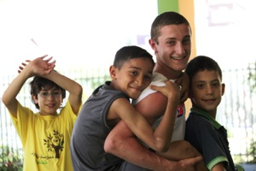
$2850 per person includes all expenses for 14 days: Meals, lodging, private guide, multicultural immersion, site fees and unforgettable experiences! Does not include airfare.

“If your intention is to enrich yourself, broaden your perspective, learn a language and create enduring relationships, then service in a community is a great place to start.”
Michael Waheed
Waldorf School of the Peninsula, Class of 2015

The adventure starts with a short filmmaking workshop, where students will learn basic skills. The following week will be spent working on a service project with young students at Tamrat El Zeitoun, the first Arab Waldorf school in Israel.
We’ll be staying at Kibbutz Harduf, home of Israel’s pioneer Waldorf school, where our evenings will be spent working on our video and getting to know members of the Harduf community.
The sightseeing tour begins in the Galilee with lunch and a tour at Beit Uri, an anthroposophical residential community for developmentally disabled children and adults. From there we will enjoy six days full of hikes, history, sites, food, scenery, friendships and unforgettable experiences.
Don’t miss this trip that is becoming a wonderful tradition for US Waldorf high school students.
• Trip leader: Waldorf parent, filmmaker and educator, Gail Evenari

“I left San Francisco with no expectations and I have returned with memories that are beyond imagination. Journeying to parts of Israel and experiencing the different cultures was unforgettable.”
Anisha Lewis
Waldorf School of the Peninsula, Class of 2015

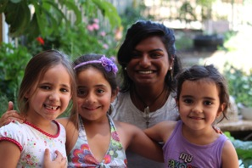
• Lodging and all meals for 14 nights in shared accommodations
• Transportation to and from Tel Aviv airport, to Harduf, to all sites
• Video training, equipment and supplies
• Educational tour with American/Israeli tour guide
• All National parks and site entrance fees and activities
• $300 tax-deductible donation to Tamrat El Zeitoun
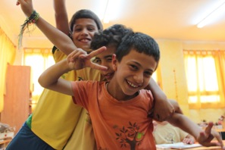
Students can raise tax-deductible donations towards their trip expenses through Maiden Voyage Productions, the nonprofit 501c3 that sponsors World Wise Adventures. Find out about fundraising by going to last year’s Team Israel page at Razoo.com .
For more information or to sign up for the trip:
Contact Gail Evenari gail@evenari.com or (650) 726-9234 Visit worldwiseadventures.org

